### ONLINE BIKE SHOWROOM

### A Skill Oriented Course report

submitted in the partial fulfillment of the requirements for the award of the degree of

# Bachelor of Technology in

**Artificial Intelligence and Data Science**

Submitted by

**BHEDAM PAVAN KUMAR**

**(21761A5475)**

Under the Guidance of

**Mr. S. Siva Ramakrishna,**

Sr. Asst. Professor



# Department of Artificial Intelligence and Data Science

## LAKIREDDY BALI REDDY COLLEGE OF ENGINEERING

**(AUTONOMOUS)**

**Accredited by NAAC with ‘A’ Grade, ISO 9001:2015 Certified Institution Approved by AICTE, New Delhi and Affiliated to JNTUK, Kakinada**

**L.B. REDDY NAGAR, MYLAVARAM, NTR., A.P.-521 230.**

**2022 - 23**

## LAKIREDDY BALI REDDY COLLEGE OF ENGINEERING



**(AUTONOMOUS)**

**Accredited by NAAC with ‘A’ Grade , ISO 9001:2015 Certified Institution Approved by AICTE, New Delhi and Affiliated to JNTUK, Kakinada**

**L.B. REDDY NAGAR, MYLAVARAM, NTR DIST., A.P.-521 230.**

[hodads@lbrce.ac.in,](mailto:hodcse@lbrce.ac.in)  Phone: 08659-222933, Fax: 08659-222931

**DEPARTMENT OF ARTIFICIAL INTELLIGENCE AND DATA SCIENCE**

# Certificate

This is to certify that the skill oriented course work entitled **ONLINE BIKE** **SHOWROOM** is a bonafide work carried out in the third semester by **BHEDAM** **PAVAN KUMAR (21761A5475),** in partial fulfillment for the award of B. Tech in Artificial Intelligence and Data Science from Jawaharlal Nehru Technological University Kakinada during the academic year 2022-23.

### Supervisor Head of the department

Mr. S. Siva RamakrishnaDr. O. Rama Devi

External Examiner

**ACKNOWLEDGEMENT**

I would like to acknowledge the contributions of the following people without whose help and guidance this report would not have been completed.

I acknowledge the counsel and support of our supervisor, **S. Siva Ramakrishna,** Sr. Asst. Professor, AI&DS Department, with respect and gratitude, whose expertise, guidance, support, encouragement, and enthusiasm has made this report possible. Their feedback vastly improved the quality of this report and provided an enthralling experience.

I am also thankful to **Dr. O. Rama Devi**, Head of the Department of Artificial Intelligence and Data Science Department, Lakireddy Bali Reddy College of Engineering, Mylavaram, for his constant encouragement, valuable suggestions and moral support and blessings.

This acknowledgement will remain incomplete if I fail to express our deep sense of obligation to my parents and God for their consistent blessings and encouragement.

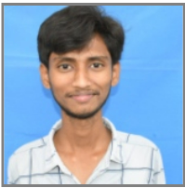

BHEDAM PAVAN KUMAR

(21761A5475)

# CONTENTS

**Particulars Page No**

1. Introduction 1-2
2. Software and Hardware Requirements 3-4
3. Technologies used in the Project 5-11
4. Implementation 12-45
5. Screen Shots 46-51
6. Conclusion 52-53
7. References 54-55

**CHAPTER-1**

**INTRODUCTION**

**INTRODUCTION**

This project is entitled as “online bike showroom” developed using HTML ,CSS ,JAVASCRIPT In this changing world, information technology and information management are going to play a important role in our life. The main purpose of this online bike showroom website is that it provides provision to customer to buy or book vehicle online.

The current system is offline system and very time taken. Our project aim creating a web application which tracks customer record online booking online vehicle record etc and it provides easy to use web based interface for customer. This “online bike showroom” website allow providing vehicles for services. If customer got any problem with his vehicle based on guarantee card they are providing services.

This website describes the complete features and prices of a bike to customer and which helps to manage the details about the bikes available in the showroom. This “online bike showroom” website is designed for users who are looking for some kind of bikes. Via this system, the users can directly access any details relevant to the bike models of their choice and they can contact the retailers as well, in case of any discussion. User can seek any information including bike details, prices as well as reviews for the bike and the company who owns the bike etc...

**CHAPTER-2**

**Software and Hardware Requirements**

**Software and Hardware Requirements**

1. **SOFTWARE REQUIREMENTS:**

* OPERATING SYSTEM **:** Windows
* FRONT END : HTML, CSS
* SCRIPTS : JavaScript
* SOFTWARE APLLICATIONS : Text editor, Web Browser

**II. HARDWARE REQUIREMENTS**

* PROCESSOR : Intel i3/i5/i7
* RAM : 4GB/8GB/16GB
* HDD : 1TB/512GB/512SSD

**CHAPTER-3**

**Technologies used in the Project**

**Technologies used in the Project**

HTML stands for Hyper Text Markup Language. It is used to design web pages using a markup language. HTML is the combination of Hypertext and Markup language. Hypertext defines the link between web pages. A markup language is used to define the text document within the tag which defines the structure of web pages. This language is used to annotate (make notes for the computer) text so that a machine can understand it and manipulate text accordingly. Most markup languages (e.g., HTML) are human-readable. The language uses tags to define what manipulation has to be done on the text.

HTML is a markup language used by the browser to manipulate text, images, and other content, in order to display it in the required format. HTML was created by Tim Berners-Lee in 1991. The first-ever version of HTML was HTML 1.0, but the first standard version was HTML 2.0, published in 1995.

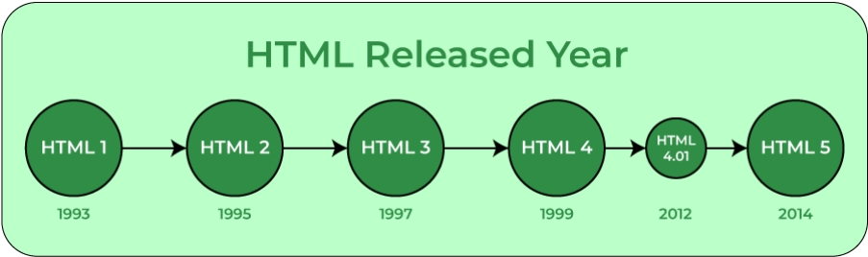

Elements and Tags: HTML uses predefined tags and elements which tell the browser how to properly display the content. Remember to include closing tags. If omitted, the browser applies the effect of the opening tag until the end of the page.7

HTML page structure: The basic structure of an HTML page is laid out below. It contains the essential building-block elements (i.e., doctype declaration, HTML, head, title, and body elements) upon which all web pages are created.

**<html>:** This is called the HTML root element. All other elements are contained within it.

**<head>:** The head tag contains the “behind the scenes” elements for a webpage.

Elements within the head aren’t visible on the front-end of a webpage. HTML elements used inside the <head> element include:

* <style>-This html tag allows us to insert styling into our webpages and make them appealing to look at with the help of CSS.
* <title>-The title is what is displayed on the top of your browser when you visit a website and contains title of the webpage that you are viewing.
* <base>-It specifies the base URL for all relative URLs in a document.
* <noscript>– Defines a section of HTML that is inserted when the scripting has been turned off in the user’s browser.
* <script>-This tag is used to add functionality in the website with the help of JavaScript.
* <meta>-This tag encloses the meta data of the website that must be loaded every time the website is visited. For e.g.: - the metadata charset allows you to use the standard UTF-8 encoding in your website. This in turn allows the users to view your webpage in the language of their choice. It is a self-closing tag.

<link>– The ‘link’ tag is used to tie together HTML, CSS and JavaScript.

**<body>:** The body tag is used to enclose all the visible content of a webpage. In other words, the body content is what the browser will show on the front-end.

An HTML document can be created using any text editor. Save the text file using **.html** or **.htm**. Once saved as an HTML document, the file can be opened as a webpage in the browser

**Features of HTML:**

* It is easy to learn and easy to use.
* It is platform-independent.
* Images, videos, and audio can be added to a web page.
* Hypertext can be added to the text.
* It is a markup language.

**Why learn HTML?**

* It is a simple markup language. Its implementation is easy.
* It is used to create a website.
* Helps in developing fundamentals about web programming.
* Boost professional career.

**Advantages:**

* HTML is used to build websites.
* It is supported by all browsers.
* It can be integrated with other languages like CSS, JavaScript, etc.

**Disadvantages:**

* HTML can only create static web pages. For dynamic web pages, other languages have to be used.
* A large amount of code has to be written to create a simple web page.
* The security feature is not good

Cascading Style Sheets, fondly referred to as CSS, is a simply designed language intended to simplify the process of making web pages presentable. CSS allows you to apply styles to web pages. More importantly, CSS enables you to do this independent of the HTML that makes up each web page. It describes how a webpage should look: it prescribes colors, fonts, spacing, and much more. In short, you can make your website look however you want. CSS lets developers and designers define how it behaves, including how elements are positioned in the browser.

While html uses tags, css uses rulesets. CSS is easy to learn and understand, but it provides powerful control over the presentation of an HTML document

* **CSS saves time:** You can write CSS once and reuse the same sheet in multiple HTML pages.

* **Easy Maintenance:** To make a global change simply change the style, and all elements in all the webpages will be updated automatically.

* **Search Engines:** CSS is considered a clean coding technique, which means search engines won’t have to struggle to “read” its content.

* **Superior styles to HTML:** CSS has a much wider array of attributes than HTML, so you can give a far better look to your HTML page in comparison to HTML attributes.

* **Offline Browsing:** CSS can store web applications locally with the help of an offline cache. Using this we can view offline websites.

**CSS versions release years:**  
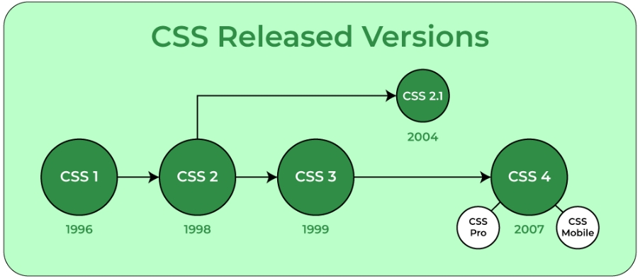**CSS Syntax:**

CSS comprises style rules that are interpreted by the browser and then applied to the corresponding elements in your document.  
A style rule set consists of a selector and declaration block.

**Selector -- h1**

**Declaration -- {color:blue;font size:12px;}**

* The selector points to the HTML element you want to style.
* The declaration block contains one or more declarations separated by semicolons.
* Each declaration includes a CSS property name and a value, separated by a colon.  
  For Example:

color is property and blue is value.  
font-size is property and 12px is value.

* CSS declaration always ends with a semicolon, and declaration blocks are surrounded by curly braces.

CSS Selectors: CSS selectors are used to “find” (or select) HTML elements based on their element name, id, class, attribute, and more.

1. UNIVERSAL SELECTORS: Rather than selecting elements of a specific type, the universal selector quite simply matches the name of any element type.

2.ELEMENT SELECTORS: The element selector selects elements based on the element name. You can select all p elements on a page like this (in this case, all p elements will be center-aligned, with a red text color).

3.DESCENDANT SELECTORS: Suppose you want to apply a style rule to a particular element only when it lies inside a particular element. As given in the following example, the style rule will apply to the em element only when it lies inside the ul tag.

**4.ID SELECTORS:**

* The id selector uses the id attribute of an HTML element to select a specific element.
* The id of an element should be unique within a page, so the id selector is used to select one unique element!
* To select an element with a specific id, write a hash (#) character, followed by the id of the element.

**5.CLASS SELECTORS:**

* The class selector selects elements with a specific class attribute.
* To select elements with a specific class, write a period (.) character, followed by the name of the class.
* In the example below, all HTML elements with class = ”center” will be green and center-aligned:

**CHAPTER-4**

**Implementation**

**Implementation**

**Home.html**

<html>

<head>

<title>Home</title>

<link rel="stylesheet" href="css.css">

</head>

<body>

<section class="header" id="header">

<div class="nav-bar">

<div class="logo">

<a href="#"><img src="logo.jpg" width="70" height="70"></a>

</div>

<div class="menu">

<ul class="ul">

<li class="li"><a href='home.html' class="active">Home</a></li>

<li class="li"><a href='moterexp.html'>Bike</a></li>

<li class="li"><a href='review.html'>Reviews</a></li>

<li class="li"><a href='#services'>services</a></li>

<li class="li"><a href='#contact'>Contact</a></li>

</ul>

</div>

</div>

<div class="hero">

<div class="row">

<div class="left-sec">

<div class="content">

<h2 style="color: black;"> UP<span> COMING</span></h2><br>

<br> <h3>Ninja H2-R</h3><p>Ninja h2r track-only variant is the fastest and most powerful production motorcycle on the market, producing a maximum of 310 horsepower (230 kW) and 326 horsepower (243 kW) </p>

</div>

<button class="discover-btn">

<a href="ninjah2r.html">Discover</a>

</button>

<div class="information"

<div class="production">

<p>production</p>

<h2>2022-2023</h2>

</div>

<div class="designer">

<p>Designer</p>

<h2>james Hillier's</h2>

</div>

</div>

</div>

<div class="slideshow-container">

<div class="mySlides">

<div class="numbertext"></div>

<img src="400.png" class="slide-size" width="700" height="700">

</div>

<div class="mySlides">

<div class="numbertext"></div>

<img src="2e.png" class="slide-size" width="650" height="650">

</div

<div class="mySlides">

<div class="numbertext"></div>

<img src="versey650.png" class="slide-size" width="700" height="700">

</div>

<a class="prev" onclick="plusSlides(-1)"></a>

<a class="next" onclick="plusSlides(1)"></a>

<br>

<br><br>

<div style="text-align:center">

<span class="dot" onclick="currentSlide(1)"></span>

<span class="dot" onclick="currentSlide(2)"></span>

<span class="dot" onclick="currentSlide(3)"></span>

</div>

</div>

</div>

</div>

</section>

<section class="services" id="services">

<a href="#" class="heading1">Our<span>services</span></a><br><br><br>

<div class="box-container">

<div class="box">

<img src="re.png" width="25" height="25">

<h3>Full Servicing</h3>

<p>

full servicing

</p>

<button class="btn1"><a href="#">read more</a></button>

</div>

<div class="box">

<img src="re.png" width="25" height="25">

<h3>Changing Engine Oil</h3>

<p>

changing engine oil

</p>

<button class="btn1"><a href="#">read more</a></button>

</div>

<div class="box">

<img src="re.png" width="25" height="25">

<h3>Vehile Washing</h3>

<p>

vehile washing

</p>

<button class="btn1"><a href="#">read more</a></button>

</div>

<div class="box">

<img src="re.png" width="25" height="25">

<h3>Chain Looping</h3>

<p>

chain looping

</p>

<button class="btn1"><a href="#">read more</a></button>

</div>

<div class="box">

<img src="re.png" width="25" height="25">

<h3>Engine Bore</h3>

<p>

engine bore

</p>

<button class="btn1"><a href="#">read more</a></button>

</div>

<div class="box">

<img src="re.png" width="25" height="25">

<h3>Reparing</h3>

<p>reparing </p>

<button class="btn1"><a href="#">read more</a></button>

</div>

</div>

</section>

<footer id="contact">

<div class="scontainer-grid">

<div class="boxs">

<h1 style="color:orangered"> Contact Details</h1>

<div class="logo">

<br><br><br><br>

Motor<span>Cycle</span>

<h1>+91 9666162081</h1>

<small>Email:Pavankumarbhedam@gmail.com</small>

</div>

<div class="boxs">

<h3>customer services</h3>

<div class="flex1">

<ul class="ul1">

<li>Help</li>

<li>Contact Us</li>

<li>Warranty</li>

<li>Terms & Conditions</li>

<li>Gift Vochers</li>

</ul>

<ul class="ul2">

<li>My Account</li>

<li>Order status</li>

<li>Payments</li>

<li>Order</li>

<li>Cancellation</li>

</ul>

</div>

</div>

<div class="social-media">

<h3>Follow <span style="color:orangered">on</span></h3>

<div class="logs">

<button class="btn2"><a href="https://www.facebook.com/pavankumarbhedam"><img src="fb.png" alt="#" class="fb" width="20" height="20"></a></button>

<button class="btn2"><a href="https://twitter.com/Pavanku11219391?t=Ho1Voa0yXyFJCvbeeicjbg&s=08"><img src="twitterw.png" alt="#" class="tw" width="20" height="20"></a></button>

<button class="btn2"><a href ="https://www.instagram.com/pavankumarbhedam/?igshid=ZDdkNTZiNTM%3D"><img src="insta.png" alt="#" class="insta" width="20" height="20"></a></button>

<button class="btn2"><a href="#"><img src="youtube.png" alt-="#" class="youtube" width="20" height="20"></a></button>

</div>

</div>

</div></div>

</footer>

<script>

var slideIndex = 0;

showSlides();

function showSlides() {

var i;

var slides = document.getElementsByClassName("mySlides");

var dots = document.getElementsByClassName("dot");

for (i = 0; i < slides.length; i++) {

slides[i].style.display = "none";

}

slideIndex++;

if (slideIndex > slides.length) { slideIndex = 1 }

for (i = 0; i < dots.length; i++) {

dots[i].className = dots[i].className.replace(" active", "");

}

slides[slideIndex - 1].style.display = "block";

dots[slideIndex - 1].className += " active";

setTimeout(showSlides, 3000);

}

</script>

</body>

</html>

**Css.css**

*{

font-family:sans-serif;

margin: 0;

padding: 0;

box-sizing: border-box;

outline: none;

border: none;

text-decoration: none;

text-transform: capitalize;

transition: all 1.5s linear;

}

html{

font-size: 62%;

overflow-x: hidden;

scroll-behavior: smooth;

}

a{

text-decoration: none;

color: #fff;

}

a:hover{

color: orangered;

}

.ul{

list-style: none;

}

.li{

display: inline-block;

}

.header{

width: 100%;

height: 100%;

background-color: #2f264e;

}

.header .nav-bar{

width: 90%;

height: 80px;

margin: auto;

color: #fff;

display: flex;

justify-content: space-between;

align-items: center;

padding: 80px;

}

.header .nav-bar .logo img{

margin-left: -20px;

border-radius: 50px;

}

.header .nav-bar .logo a{

font-size: 30px;

font-weight: 700;

text-transform: uppercase;

}

.header .nav-bar .menu ul li{

margin-right: 30px;

}

.header .nav-bar .menu ul li a{

font-size: 15px;

letter-spacing: 2px;

padding: 10px;

border-radius: 5px;

text-transform: capitalize;

opacity: 0.6;

}

.header .nav-bar .menu ul li a .active{

opacity: 1;

}

.header .nav-bar .menu ul li a:hover{

opacity: 1;

}

.hero{

width: 100%;

}

.hero .row{

width: 90%;

display: flex;

justify-items: space-between;

align-items: center;

padding-top: 20px;

margin: auto;

}

.hero .row .left-sec{

width:30%;

margin-top: -10%;

margin-left: 45px;

}

.hero .row .left-sec h2{

font-size: 55px;

color: #fff;

text-transform: capitalize;

}

.hero .row .left-sec h3{

font-size: 35px;

color: red;

text-transform: capitalize;

}

.hero .row .left-sec h2 span{

color: orangered;

}

.hero .row .left-sec p{

margin: 20px 0;

color: #fff;

line-height: 30px;

font-size: 13px;

}

.hero .row .left-sec .discover-btn{

display: flex;

align-items: center;

outline: none;

border-radius: 50px;

cursor: pointer;

margin-top: 50px;

padding: 0 25px;

border: 3px solid #009688;

background-color: greenyellow;

box-shadow: 5px 7px 20px #000;

}

.hero .row .left-sec .discover-btn a{

color: #000;

font-size: 25px;

letter-spacing: 2px;

margin-right: 15px;

text-transform: capitalize;

}

.hero .row .left-sec .discover-btn:hover{

background:white;

transform: scale(1.2);

}

.hero .information{

width: 100%;

display: flex;

margin-top: 100px;

}

.hero .information .production{

margin-right: 50px;

line-height: 3px;

}

.hero .information .production h2{

font-size: 15px;

letter-spacing: 1px;

}

.hero .information .production p{

font-size: 10px;

padding-right: 0;

letter-spacing: 1px;

}

.hero .information .Designer{

margin-right: 50px;

line-height: 3px;

}

.hero .information .Designer h2{

font-size: 15px;

letter-spacing: 0.5px;

}

.hero .information .Designer p{

font-size: 10px;

padding-right: 0;

letter-spacing: 1px;

}

.slideshow-container {

margin-top: -5%;

max-width: 75%;

position: relative;

margin-left: 10%;

}

.slide-size{

width: 100%;

}

.prev, .next {

cursor: pointer;

position: absolute;

top: 50%;

width: auto;

margin-top: -22px;

padding: 16px;

color: white;

font-weight: bold;

font-size: 18px;

transition: 0.6s ease;

border-radius: 0 3px 3px 0;

user-select: none;

}

.next {

right: 0;

border-radius: 0px 0 0 3px;

}

.numbertext {

color: #f2f2f2;

font-size: 12px;

padding: 8px 12px;

position: absolute;

top: 0;

}

.services{

padding: 1rem 6.5%;

background-color: rgba(0,0,0,0.1);

}

.services .box-container{

display: grid;

grid-template-columns: repeat(auto-fit,minmax(30rem,1fr));

gap: 5.5rem;

}

.services .box-container .box{

text-align: center;

padding: 2rem;

box-shadow: black;

border: 1px solid red;

border-radius: 10px;

}

.services .box-container .box h3{

margin-top: 10%;

font-size: 2.2rem;

color: black;

}

.services .box-container .box img{

border: 1px solid white;

background: orangered;

border-radius: 20px;

}

.services .box-container .box p{

font-size: 1.3rem;

padding: 2rem 0;

}

.services .box-container .box:hover{

background: orangered;

}

.services .box-container .box:hover h3{

color: #fff;

}

.services .box-container .box:hover p{

color: #fff;

}

.services .box-container .box:hover img{

background: #fff;

}

.btn1{

width: 100PX;

padding: 15px 0;

text-align: center;

margin: 20px 30px;

border-radius: 25px;

font-weight: bold;

border: 1px solid #009688;

background: transparent;

color: #fff;

cursor: pointer;

position: relative;

overflow: hidden;

background-color: yellowgreen;

}

.btn1:hover {

background:white;

transform: scale(1.2);

}

.btn1 a{

color: black;

}

.heading1{

text-align: center;

padding-bottom: 2rem;

font-size: 5rem;

color: #000;

}

.heading1 span{

position: relative;

z-index: 0;

color: orangered;

}

footer{

padding: 5%;

padding: 1rem 6.5%;

background: black;

height: 30%;

width: 100%;

}

.scontainer-grid .boxs .logo{

margin-left: 10%;

}

.scontainer-grid .boxs .logo span{

color:orangered;

}

.scontainer-grid .boxs{

margin-top: 1%;

color: #fff;

}

.scontainer-grid .boxs h3{

margin-top: -5.5%;

margin-left: 36%;

}

.scontainer-grid .boxs .flex1{

margin-top: 0;

}

.scontainer-grid .boxs .flex1 .ul1{

margin-left: 35%;

}

.scontainer-grid .boxs .flex1 .ul2{

margin-left: 43%;

margin-top: -4%;

}

.scontainer-grid .boxs .social-media h3{

margin-top: -6%;

margin-left: 78%;

}

.scontainer-grid .boxs .social-media .logs{

margin-top: 1%;

margin-left: 60%;

display: flex;

justify-content: space-between;

}

.scontainer-grid .boxs .social-media .fb{

background: white;

}

.scontainer-grid .boxs .social-media .tw{

background: white;

}

.scontainer-grid .boxs .social-media .insta{

background: white;

}

.scontainer-grid .boxs .social-media .youtube{

background: white;

}

.scontainer-grid .boxs .social-media .logs .btn2{

margin-top:4%;

width: 50PX;

text-align: center;

padding: 10px 0;

border-radius: 50px;

border: 2px solid black;

cursor: pointer;

position: relative;

overflow: hidden;

}

.scontainer-grid .boxs .social-media .logs .btn2:hover{

background: red;

}

**Bike.html**

<html>

<head>

<link rel="stylesheet" href="exp.css">

</head>

<body>

<section class="services1">

<a href="#" class="heading">Our<span>Motorcycles</span></a><br>

<div class="btns1">

<button class="btn4"><a href="home.html">Back to Home</a></button>

</div>

<div class="box-container">

<div class="box">

<a href="z650black.html" target="_self"><img src="z650black.jpg" class="img"></a>

</div>

</div>

<div class="main">

<div class="box-container">

<div class="box">

<a href="versey650.html" target="_self"><img src="versey650.png" class="img"></a>

<div class="des">

<br> <h2 id="bike_name">VERSYS 650</h2><br>

<p>Rs 736000</p>

</div>

</div>

<div class="box-container">

<div class="box">

<a href="ninjah2r.html" target="_self"><img src="ninjah2r.jpg" class="img"></a>

<div class="des">

<BR><h2 id="bike_name">NINJA H2R</h2><BR>

<p>Rs 7900000</p>

</div>

</div>

</div>

<div class="box-container">

<div class="box">

<a href="400.html" target="_self"><img src="400.png" class="img"></a>

<div class="des">

<BR><h2 id="bike_name">NINJA 400</h2><BR>

<p>Rs 500000</p>

</div>

</div>

</div>

<div class="box-container">

<div class="box">

<a href="z650black.html" target="_self"><img src="z650.jpg" class="img"></a>

<div class="des">

<BR><h2 id="bike_name">KAWASAKI Z650RS</h2><BR>

<p>Rs 643000</p>

</div>

</div>

</div>

<div class="box-container">

<div class="box">

<a href="z900.html" target="_self"><img src="z900.png" class="img"></a>

<div class="des">

<BR><h2 id="bike_name">KAWASAKI Z900</h2><BR>

<p>Rs 300000</p>

</div>

</div>

</div>

<div class="box-container">

<div class="box">

<a href="zx10r.html" target="_self"><img src="zx10r.png" class="img"></a>

<div class="des">

<BR><h2 id="bike_name">NINJA ZX-1OR</h2><BR>

<p>Rs 170000</p>

</div>

</div>

</div>

</div>

<br><br><br>

<div class="box-container">

<div class="box">

<a href="vulcan.html" target="_self"><img src="vulcan.jpg" class="img"></a>

<div class="des">

<BR><h2 id="bike_name">VULCAN S</h2><BR>

<p>RS 1600000</p>

</div>

</div>

<div class="box-container">

<div class="box">

<a href="kx250.html" target="_self"><img src="kx250.jpg" class="img"></a>

<div class="des">

<BR><h2 id="bike_name">KAWASAKI KX-250R</h2><BR>

<p>RS 799000</p>

</div>

</div>

</div>

<div class="box-container">

<div class="box">

<a href="1000sx.html" target="_self"><img src="1000sx.jpg" class="img"></a>

<div class="des">

<BR><h2 id="bike_name">NINJA 1000SX</h2><BR>

<p>RS 1198000</p>

</div>

</div>

</div>

<div class="box-container">

<div class="box">

<a href="z650rs.html" target="_self"><img src="z650rs.jpg" class="img"></a>

<div class="des">

<BR><h2 id="bike_name">KAWASAKI Z650RS</h2><BR>

<p>Rs 692000</p>

</div>

</div>

</div>

<div class="box-container">

<div class="box">

<a href="w800.html" target="_self"><img src="w800.jpg" class="img"></a>

<div class="des">

<BR><h2 id="bike_name">KAWASAKI W800</h2><BR>

<p>Rs 733000</p>

</div>

</div>

</div>

<div class="box-container">

<div class="box">

<a href="10rr.html" target="_self"><img src="10rr.jpg" class="img"></a>

<div class="des">

<BR><h2 id="bike_name">NINJA ZX-1OR</h2><BR>

<p>Rs 160000</p>

</div>

</div>

</div>

</div>

</div>

</section>

<br><br><br>

</body>

</html>

**exp.css**

*{

font-family:sans-serif;

margin: 0;

padding: 0;

box-sizing: border-box;

outline: none;

border: none;

text-decoration: none;

text-transform: capitalize;

transition: all 1.5s linear;

}

html{

font-size: 62%;

overflow-x: hidden;

scroll-behavior: smooth;

}

.header{

position: fixed;

top: 0;

left: 0;

right: 0;

z-index: 999;

background: #fff;

display: flex;

align-items: center;

justify-content: space-between;

padding: 3rem 9%;

}

.header .logo{

font-size: 2.5rem;

color: orangered;

font-weight: bold;

}

.header .logo span{

color: #000;

}

.header .navbar a{

font-size: 1.7rem;

margin: 0 1rem;

color: #000;

}

.header .navbar a:hover{

color: orangered;

}

.home{

padding-top: 10rem;

text-align: center;

overflow: hidden;

}

.home h1{

font-size: 4.5vw;

text-transform: uppercase;

color: #000;

}

.home img{

width: 100%;

margin-top: -170px;

}

.btn{

width: 200PX;

padding: 15px 0;

text-align: center;

margin: 20px 30px;

border-radius: 25px;

font-weight: bold;

border: 2px solid #009688;

background: transparent;

color: #fff;

cursor: pointer;

position: relative;

overflow: hidden;

background-color: yellowgreen;

}

.btn:hover {

background:white;

width:20%;

}

.btn a{

color: black;

}

.heading{

text-align: center;

padding-bottom: 2rem;

font-size: 4rem;

color: #000;

}

.heading span{

position: relative;

z-index: 0;

color: orangered;

}

btns1 .btn4{

margin-top: -2%;

margin-left: 89%;

width: 100PX;

padding: 1px 0;

text-align: center;

border-radius: 25px;

font-weight: bold;

border: 2px solid #009688;

color: #fff;

cursor: pointer;

position: relative;

overflow: hidden;

background: yellowgreen;

}

.btns1 .btn4:hover{

transform: scale(1.1);

background: white;

}

.btns1 a{

color: black;

}

.services1{

padding: 1rem 6.5%;

}

.services1 .box-container{

display: grid;

grid-template-columns: repeat(auto-fit,minmax(30rem,1fr));

gap: 5.5rem;

}

.services1 .box-container .box{

text-align: center;

padding: 2rem;

box-shadow: black;

border: 1px dotted white;

border-radius: 10px;

}

.services1 .box-container .box img{

/* border: 1px solid white;*/

background: white;

border-radius: 20px;

}

.main .box-container .box:hover{

transform: scale(1.1);

}

.main .box-container .box .des{

margin-left: 02%;

color: black;

font-weight: 100;

background-color: rgba(0,0,0,0.1);

border-radius: 20px;

}

.main .box-container .box .des #bike_name{

margin-left: 02%;

color: orangered;

}

.main .box-container .box .des #spct{

margin-left: 130%;

color: red;

}

.img{

width: 100%;

height: 90%;

}

/* reviwe

.review img{

margin-left: 36%;

display: flex;

justify-content: space-between;

height: 30%;

width: 30%;

border: 1px solid red;

}*/

/* price */

.h1{

padding: 5%;

margin-top: 15%;

margin-left: 5%;

border: 1px solid red;

height: 52%;

width:35%

}

.h1:hover{

background: orangered;

}

.h2:hover{

color:white;

}

.btn2 button{

margin-top: -07%;

margin-left: 28%;

width: 100PX;

padding: 1px 0;

text-align: center;

border-radius: 25px;

font-weight: bold;

border: 2px solid #009688;

color: #fff;

cursor: pointer;

position: relative;

overflow: hidden;

background: yellowgreen;

}

.btns .btn3{

margin-top: -10%;

margin-left: 23%;

width: 100PX;

padding: 1px 0;

text-align: center;

border-radius: 25px;

font-weight: bold;

border: 2px solid #009688;

color: #fff;

cursor: pointer;

position: relative;

overflow: hidden;

background: yellowgreen;

}

.btns .btn2{

margin-top: -10%;

margin-left: 3%;

width: 100PX;

padding: 1px 0;

text-align: center;

border-radius: 25px;

font-weight: bold;

border: 2px solid #009688;

color: #fff;

cursor: pointer;

position: relative;

overflow: hidden;

background: yellowgreen;

}

.btns .btn2:hover{

transform: scale(1.1);

background: white;

}

.btns .btn3:hover{

transform: scale(1.1);

background: white;

}

.btns a{

color: black;

}

.bikes{

margin-left: 55%;

margin-top: -30%;

}

**review.html**

<html>

<head>

<title>reviews</title>

<link rel="stylesheet" href="review.css">

</head>

<body>

<section id="testimonials">

<!--heading--->

<div class="testimonial-heading">

<a href="#" class="heading"><span>Customer</span>Review</a>

<div class="btns">

<button class="btn3"><a href="home.html">Back to Home</a></button>

</div>

</div>

<div class="testimonial-box-container">

<div class="testimonial-box">

<div class="box-top">

<div class="profile">

<div class="profile-img">

<img src="re1.jpg" />

</div>

<div class="name-user">

<strong>ravan</strong>

<span>queenlessking@gmail.com</span>

</div>

</div>

<div class="reviews">

<img src="star1.png" height="20px" width="20px">

<img src="star1.png" height="20px" width="20px">

<img src="star1.png" height="20px" width="20px">

<img src="star1.png" height="20px" width="20px">

<img src="start2.png" height="20px" width="20px">

</div>

</div>

<div class="client-comment">

<p>Worst showroom mechanic not available and spare parts not available mechanic dont have experience he didn't find the probl …</p>

</div>

</div>

<div class="testimonial-box">

<div class="box-top">

<div class="profile">

<div class="profile-img">

<img src="re2.webp" />

</div>

<div class="name-user">

<strong>mahesh</strong>

<span>lipsticksploiler@gmail.com</span>

</div>

</div>

<div class="reviews">

<img src="star1.png" height="20px" width="20px">

<img src="star1.png" height="20px" width="20px">

<img src="star1.png" height="20px" width="20px">

<img src="start2.png" height="20px" width="20px">

<img src="start2.png" height="20px" width="20px">

</div>

</div>

<div class="client-comment">

<p>Irresponsible and reckless response from the owner and he doesn't know how to respond and respect to the customer.Worst servicing that i never seen before.

I strongly suggest to don't buy any vehicle in this showroom.</p>

</div>

</div>

<div class="testimonial-box">

<div class="box-top">

<div class="profile">

<div class="profile-img">

<img src="re3.jpg" />

</div>

<div class="name-user">

<strong>petamma</strong>

<span>kinglessqueen@gmail.com</span>

</div>

</div>

<div class="reviews">

<img src="star1.png" height="20px" width="20px">

<img src="star1.png" height="20px" width="20px">

<img src="star1.png" height="20px" width="20px">

<img src="star1.png" height="20px" width="20px">

<img src="star1.png" height="20px" width="20px">

</div>

</div>

<div class="client-comment">

<p>Very good servicing and friendly staff</p>

</div>

</div>

<div class="testimonial-box">

<div class="box-top">

<div class="profile">

<div class="profile-img">

<img src="re4.png" />

</div>

<div class="name-user">

<strong>Oliva</strong>

<span>Olivababy@gmail.com</span>

</div>

</div>

<div class="reviews">

<img src="star1.png" height="20px" width="20px">

<img src="star1.png" height="20px" width="20px">

<img src="star1.png" height="20px" width="20px">

<img src="star1.png" height="20px" width="20px">

<img src="star1.png" height="20px" width="20px">

</div>

</div>

<div class="client-comment">

<p>Good servicing and friendly staff </p>

</div>

</div>

</div>

</section>

<h2 id="fh2">WE APPRECIATE YOUR REVIEW!</h2>

<h6 id="fh6">Your review will help us to improve services.</h6>

<form id="feedback" action="">

<div class="pinfo">Your personal info</div>

<div class="form-group">

<div class="col-md-4 inputGroupContainer">

<div class="input-group">

<span class="input-group-addon"><img src="profile.png" height="20px" width="20px"></span>

<input name="name" placeholder="John Doe" class="form-control" type="text">

</div>

</div>

</div>

<div class="form-group">

<div class="col-md-4 inputGroupContainer">

<div class="input-group">

<span class="input-group-addon"><img src="gmail.png" height="20px" width="20px"></span>

<input name="email" type="email" class="form-control" placeholder="john.doe@yahoo.com">

</div>

</div>

</div>

<div class="form-group">

<div class="col-md-4 inputGroupContainer">

<div class="input-group">

</div>

</div>

</div>

<div class="pinfo">Rate our overall services.</div>

<div class="form-group">

<div class="col-md-4 inputGroupContainer">

<div class="input-group">

<span class="input-group-addon"><img src="start2.png" height="20px" width="20px"></span>

<select class="form-control" id="rate">

<option value="1star">1</option>

<option value="2stars">2</option>

<option value="3stars">3</option>

<option value="4stars">4</option>

<option value="5stars">5</option>

</select>

</div>

</div>

</div>

<div class="pinfo">Write your feedback.</div>

<div class="form-group">

<div class="col-md-4 inputGroupContainer">

<div class="input-group">

<span class="input-group-addon"><img src="comment.png" height="20px" width="20px"></span>

<textarea class="form-control" id="review" rows="3"></textarea>

</div>

</div>

</div>

<button type="submit" class="btn btn-primary">Submit</button>

</form>

</body>

</html>

**review.css**

*{

margin: 0px;

padding: 0px;

font-family: poppins;

box-sizing: border-box;

}

a{

text-decoration: none;

}

#testimonials{

display: flex;

justify-content: center;

align-items: center;

flex-direction: column;

width:100%;

}

.testimonial-heading{

letter-spacing: 1px;

margin: 30px 0px;

padding: 10px 20px;

display: flex;

flex-direction: column;

justify-content: center;

align-items: center;

}

.testimonial-heading .heading{

margin-top: 8%;

color: orangered;

font-size: 30px;

margin-left: -360%;

}

.testimonial-heading .heading span{

color:black

}

.testimonial-heading h1{

font-size: 2.2rem;

font-weight: 500;

background-color: #202020;

color: #ffffff;

padding: 10px 20px;

}

.testimonial-box-container{

display: flex;

justify-content: center;

align-items: center;

flex-wrap: wrap;

width:100%;

}

.testimonial-box{

width:500px;

box-shadow: 2px 2px 30px rgba(0,0,0,0.1);

background-color: #ffffff;

padding: 20px;

margin: 15px;

cursor: pointer;

}

.profile-img{

width:50px;

height: 50px;

border-radius: 50%;

overflow: hidden;

margin-right: 10px;

}

.profile-img img{

width: 100%;

height: 100%;

object-fit: cover;

object-position: center;

}

.profile{

display: flex;

align-items: center;

}

.name-user{

display: flex;

flex-direction: column;

}

.name-user strong{

color: #3d3d3d;

font-size: 1.1rem;

letter-spacing: 0.5px;

}

.name-user span{

color: #979797;

font-size: 0.8rem;

}

.reviews{

color: #f9d71c;

}

.box-top{

display: flex;

justify-content: space-between;

align-items: center;

margin-bottom: 20px;

}

.client-comment p{

font-size: 0.9rem;

color: #4b4b4b;

}

.testimonial-box:hover{

transform: translateY(-10px);

transition: all ease 0.3s;

}

@media(max-width:1060px){

.testimonial-box{

width:45%;

padding: 10px;

}

}

@media(max-width:790px){

.testimonial-box{

width:100%;

}

.testimonial-heading h1{

font-size: 1.4rem;

}

}

@media(max-width:340px){

.box-top{

flex-wrap: wrap;

margin-bottom: 10px;

}

.reviews{

margin-top: 10px;

}

}

::selection{

color: #ffffff;

background-color: #252525;

}

#feedback {

max-width: 60%;

width: 100%;

margin: 10px auto;

padding: 20px;

border: solid 1px #f1f1f1;

background: #fbfbfb;

box-shadow: #e6e6e6 0 0 4px ;

border-radius: 0.25rem;

}

@media (max-width: 720px) {

#feedback{

max-width: 90%;

}

}

@media (max-width: 500px) {

#feedback{

padding: 10px;

}

}

#fh2{

padding: 2px 15px;

color: #ff4d4d;

text-align: center;

}

@media (max-width: 400px) {

#fh2{

font-size: 20px;

}

}

#fh6 {

padding: 2px 15px;

color: #4d0er;

text-align: center;

font-weight: normal;

}

@media (max-width: 400px) {

#fh6{

font-size: 12px;

}

}

.pinfo {

margin: 8px auto;

font-weight: bold;

line-height: 1.5;

color: #0d0d0d;

}

.form-group {

margin-bottom: 1rem;

}

.form-control:focus {

color: #696060;

background-color: #fff;

border-color: #5cb3fd;

outline: none;

}

.form-control::-webkit-input-placeholder {

color: #F34949;

opacity: 1;

}

.form-control::-moz-placeholder {

color: brown;

opacity: 1;

}

.form-control:-ms-input-placeholder {

color: blue;

opacity: 1;

}

.form-control::placeholder {

color: white;

opacity: 1;

}

.form-control:disabled, .form-control[readonly] {

background-color: red;

opacity: 1;

}

.form-control:disabled {

cursor: not-allowed;

}

select.form-control:not([size]):not([multiple]) {

height: calc(2.25rem + 2px);

}

select.form-control:focus::-ms-value {

color: green;

background-color: #fff;

}

.form-control-file,

.form-control-range {

display: block;

}

.input-group {

position: relative;

display: -webkit-box;

display: -webkit-flex;

display: -ms-flexbox;

display: flex;

width: 100%;

}

.input-group .form-control {

position: relative;

z-index: 2;

-webkit-box-flex: 1;

-webkit-flex: 1 1 auto;

-ms-flex: 1 1 auto;

flex: 1 1 auto;

width: 1%;

margin-bottom: 0;

}

.input-group-addon,

.input-group-btn {

white-space: nowrap;

vertical-align: middle;

}

.input-group-addon {

width: 45px;

padding: 0.5rem 0.75rem;

margin-bottom: 0;

font-size: 1rem;

font-weight: normal;

line-height: 1.25;

color: #2e2e2e;

text-align: center;

background-color: #eceeef;

border: 1px solid rgba(0, 0, 0, 0.15);

border-radius: 0.25rem;

}

.input-group-addon.form-control-sm,

.input-group-sm > .input-group-addon,

.input-group-sm > .input-group-btn > .input-group-addon.btn {

padding: 0.25rem 0.5rem;

font-size: 0.875rem;

border-radius: 0.2rem;

}

.input-group-addon.form-control-lg,

.input-group-lg > .input-group-addon,

.input-group-lg > .input-group-btn > .input-group-addon.btn {

padding: 0.75rem 1.5rem;

font-size: 1.25rem;

border-radius: 0.3rem;

}

.input-group-addon input[type="radio"],

.input-group-addon input[type="checkbox"] {

margin-top: 0;

}

.input-group .form-control:not(:last-child),

.input-group-addon:not(:last-child),

.input-group-btn:not(:last-child) > .btn,

.input-group-btn:not(:last-child) > .btn-group > .btn,

.input-group-btn:not(:last-child) > .dropdown-toggle,

.input-group-btn:not(:first-child) > .btn:not(:last-child):not(.dropdown-toggle),

.input-group-btn:not(:first-child) > .btn-group:not(:last-child) > .btn {

border-bottom-right-radius: 0;

border-top-right-radius: 0;

}

.input-group-addon:not(:last-child) {

border-right: 0;

}

.input-group .form-control:not(:first-child),

.input-group-addon:not(:first-child),

.input-group-btn:not(:first-child) > .btn,

.input-group-btn:not(:first-child) > .btn-group > .btn,

.input-group-btn:not(:first-child) > .dropdown-toggle,

.input-group-btn:not(:last-child) > .btn:not(:first-child),

.input-group-btn:not(:last-child) > .btn-group:not(:first-child) > .btn {

border-bottom-left-radius: 0;

border-top-left-radius: 0;

}

.form-control + .input-group-addon:not(:first-child) {

border-left: 0;

}

.btn {

display: inline-block;

font-weight: normal;

line-height: 1.25;

text-align: center;

border: 1px solid transparent;

padding: 0.5rem 1rem;

font-size: 1rem;

border-radius: 0.25rem;

}

.btn:focus, .btn:hover {

text-decoration: none;

}

.btn:focus, .btn.focus {

outline: 0;

-webkit-box-shadow: 0 0 0 2px rgba(2, 117, 216, 0.25);

box-shadow: 0 0 0 2px rgba(2, 117, 216, 0.25);

}

.btn.disabled, .btn:disabled {

cursor: not-allowed;

opacity: .65;

}

.btn:active, .btn.active {

background-image: none;

}

a.btn.disabled,

fieldset[disabled] a.btn {

pointer-events: none;

}

.btn-primary {

color: #fff;

background-color: #0275d8;

border-color: #0275d8;

}

.btn-primary:hover {

color: #fff;

background-color: #025aa5;

border-color: #01549b;

}

.btn-primary:focus, .btn-primary.focus {

-webkit-box-shadow: 0 0 0 2px rgba(2, 117, 216, 0.5);

box-shadow: 0 0 0 2px rgba(2, 117, 216, 0.5);

}

.btns .btn3{

margin-top: -30%;

margin-left: 450%;

width: 100PX;

padding: 1px 0;

text-align: center;

border-radius: 25px;

font-weight: bold;

border: 2px solid #009688;

color: #fff;

cursor: pointer;

position: relative;

overflow: hidden;

background: yellowgreen;

}

.btns .btn3:hover{

transform: scale(1.1);

background: white;

}

.btns a{

color: black;

}

**CHAPTER-5**

**SCREEN SHOTS**

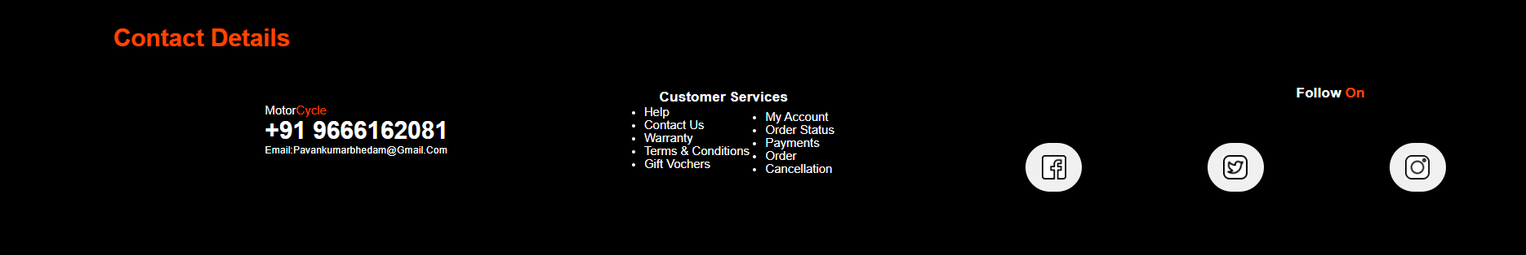**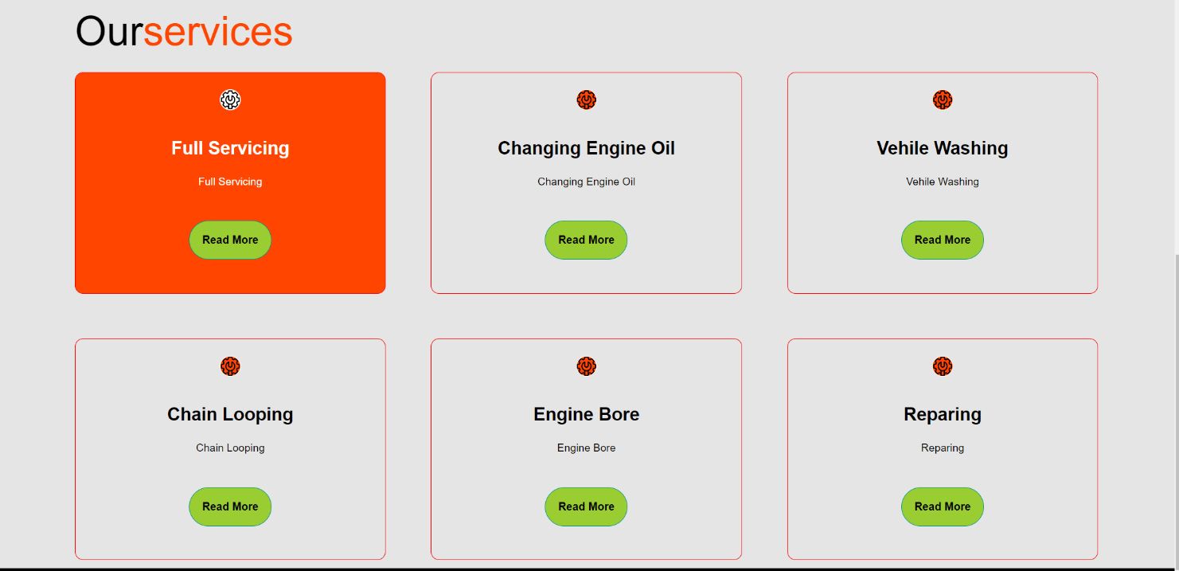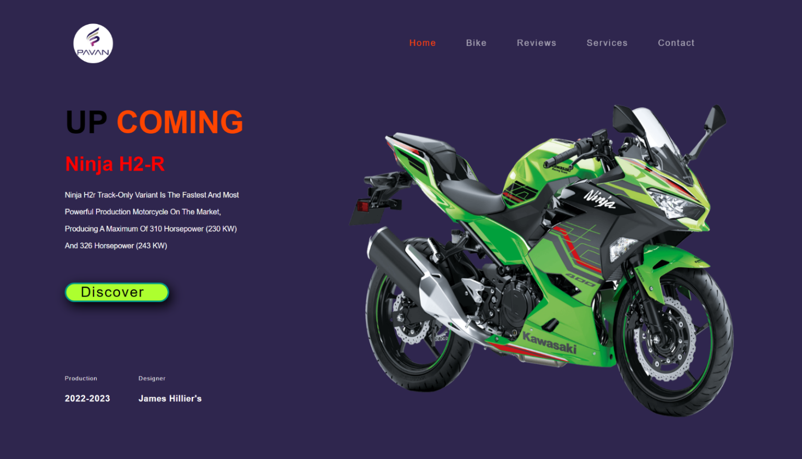SCREEN SHOTS:**

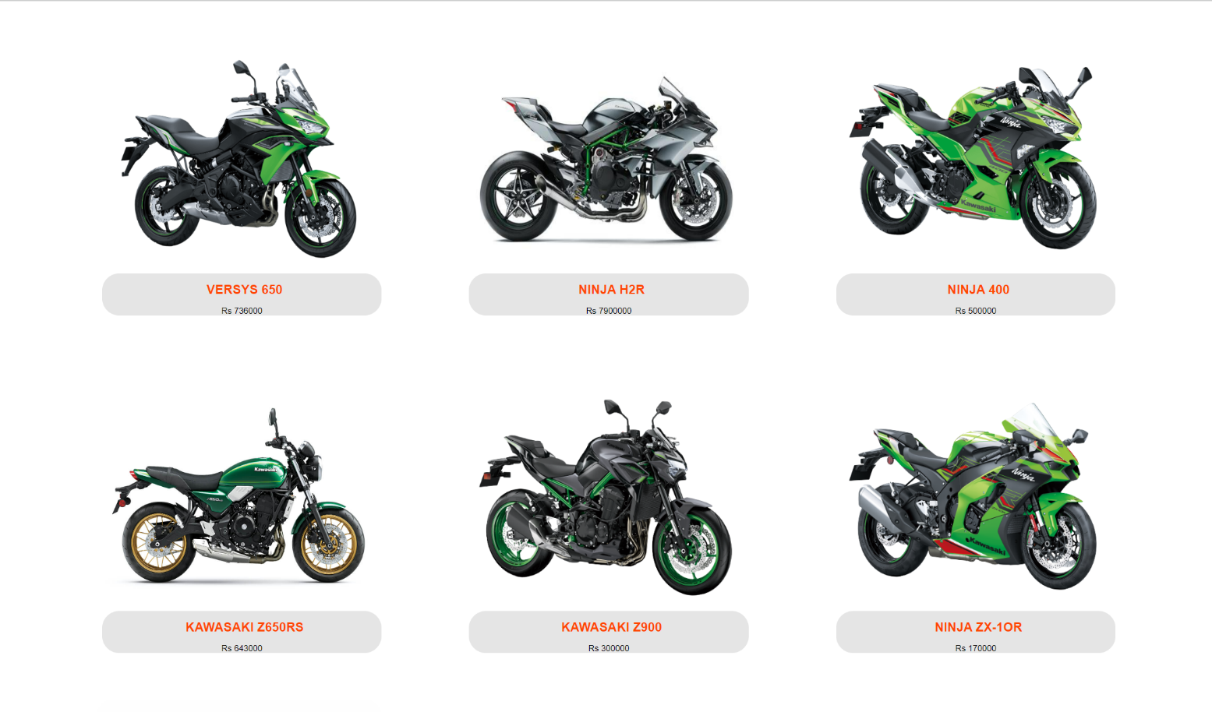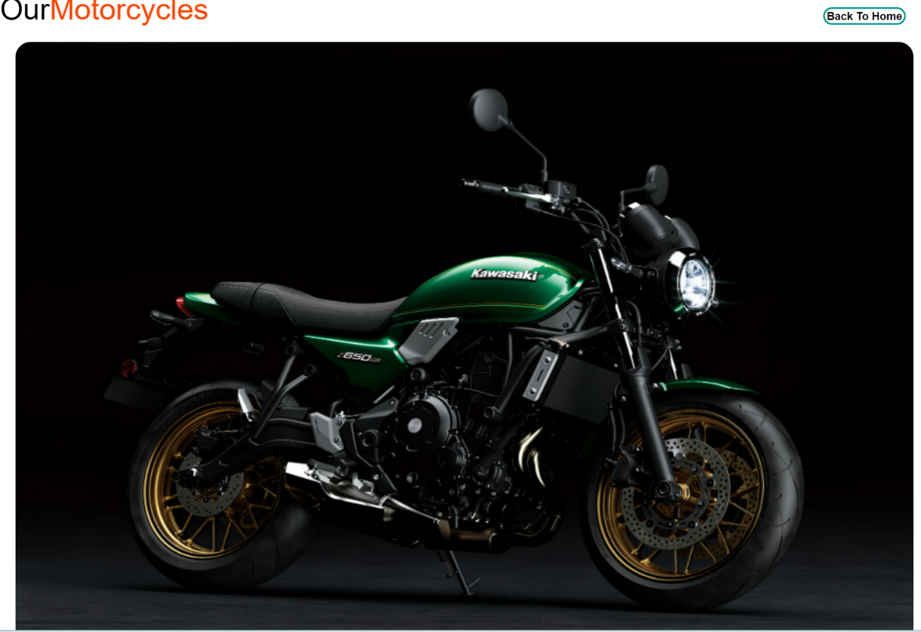

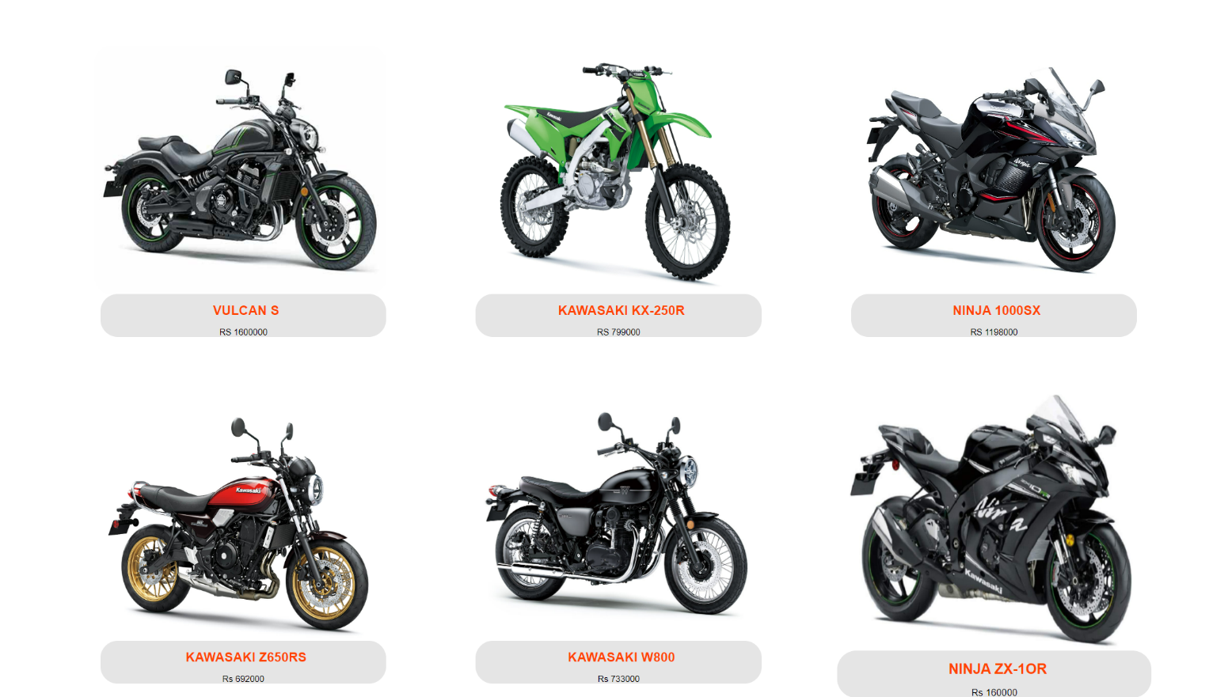

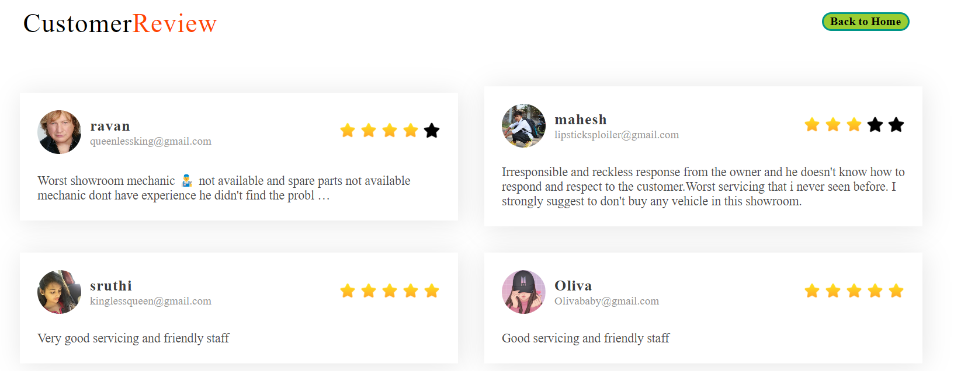

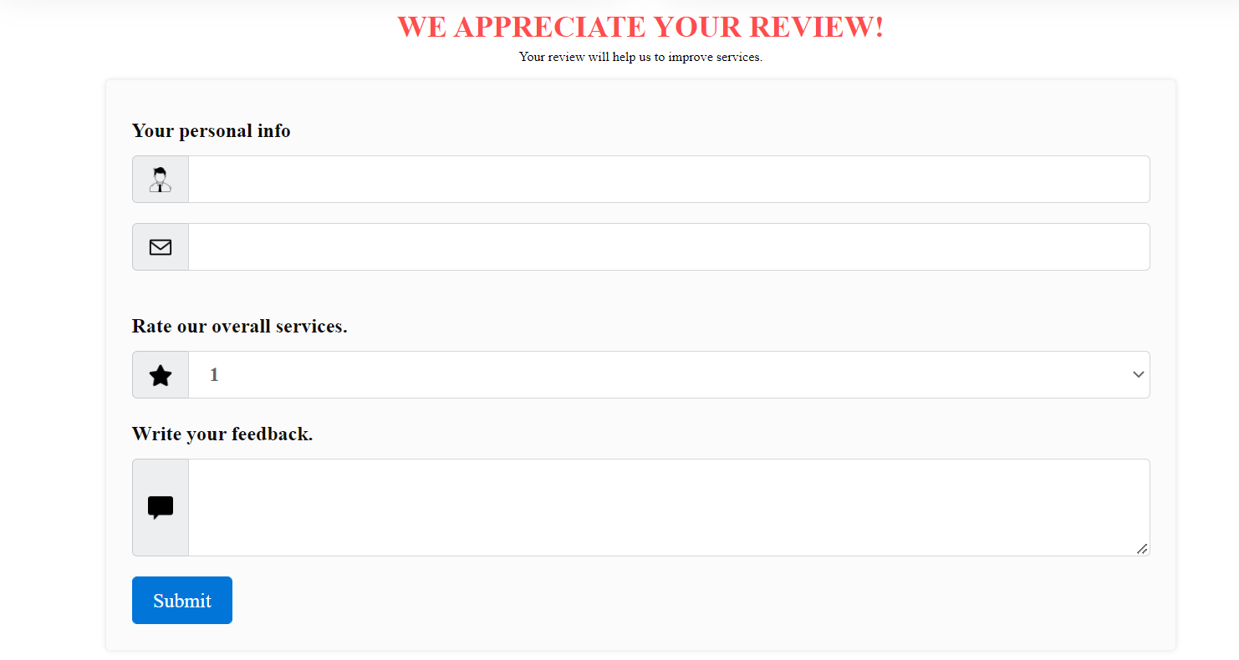

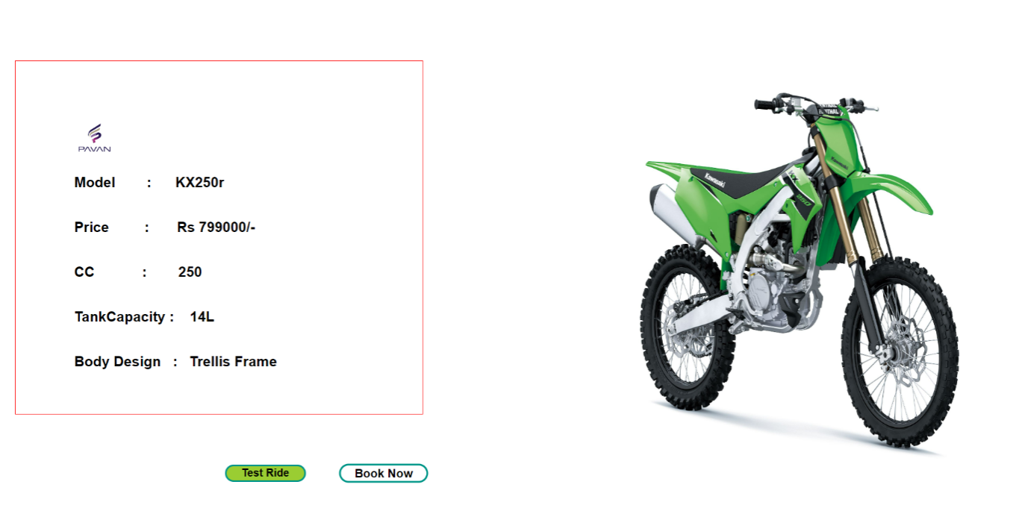

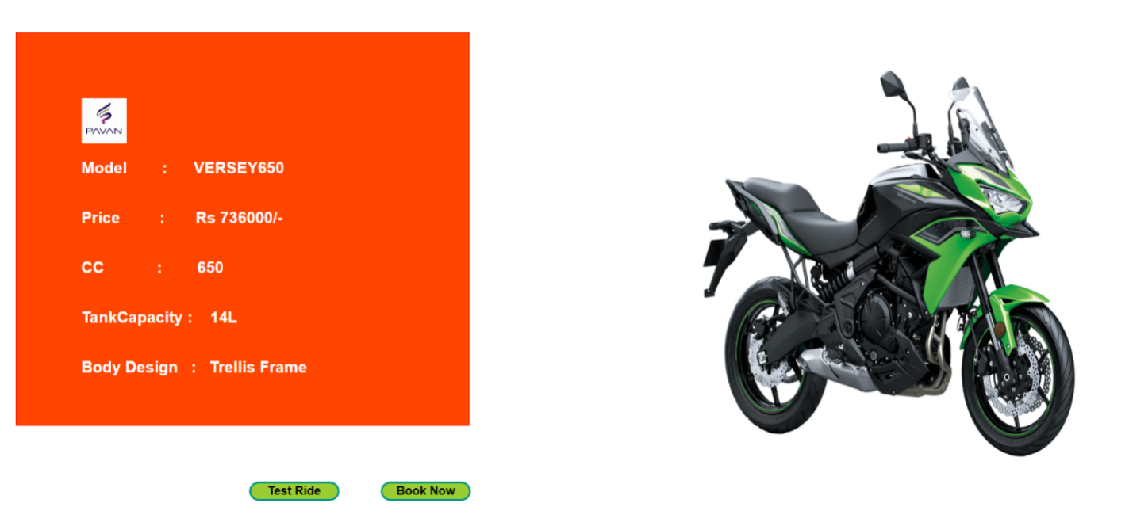

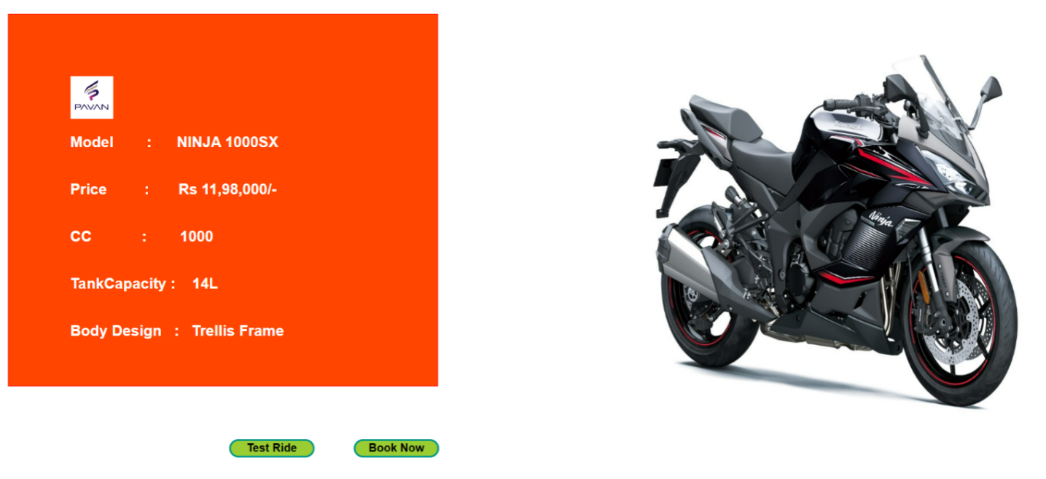

**CHAPTER-6**

**Conclusion**  **Conclusion**

The given project titled “ONLINE BIKE SHOWROOM” is successfully completed and the reports are also generated. Validation is done accordingly and the website is designed to be as interactive as possible. Listing them side by side provides all necessary option, any one of the desired option can be selected and the corresponding operation is performed. The online bike showroom is one of the most effective website for users who are looking for data related to bikes and who do not have enough time to spend.

**CHAPTER-7**

**References**

**References**

1. <https://kawasaki-india.com/bikes/ninja-h2r/>
2. <https://www.autox.com/new-bikes/kawasaki/>
3. <https://www.w3schools.com/css/default.asp>
4. <https://youtu.be/HaVd86XQp3s>